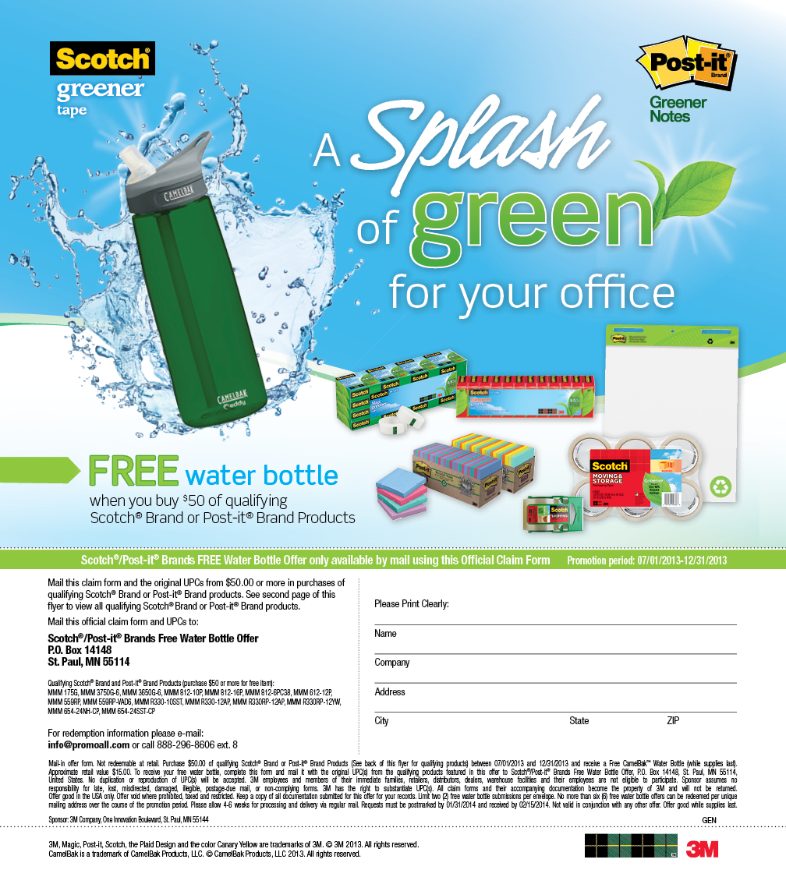

Dealer Imprint Area
(Type onto this text to edit)

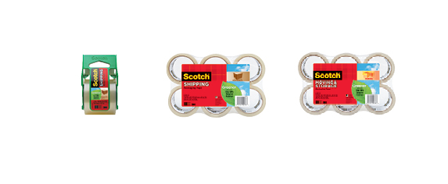

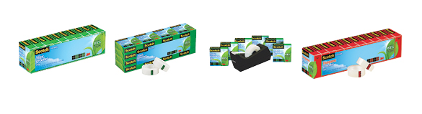
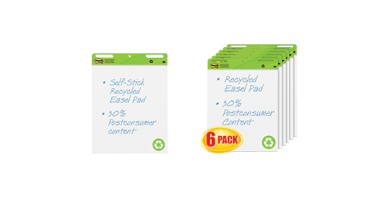
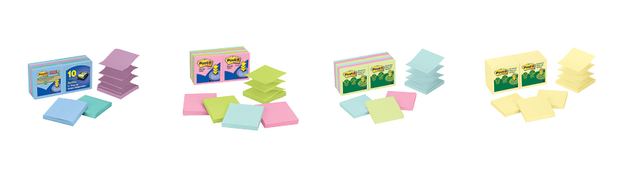
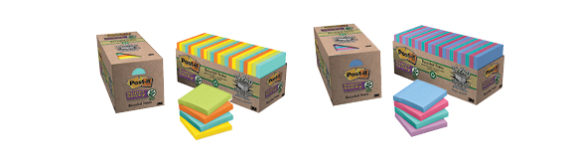
POST-IT® POP-UP NOTES
J | MMM R330-10SST | Post-it® Super Sticky Pop-up Notes, 3"x 3", Tropical Colors, 90 Shts/Pad, 10 PADS/PK | $ 24.98 | $ XX.XX | 53200019792
K | MMM R330-12AP | Post-it® Pop-up Notes, 3"x 3", Assorted Pastel Colors, 100 Shts/Pad, 12 PADS/PK | $ 25.03 | $ XX.XX | 21200527418
L | MMM R330RP-12AP | Post-it® Greener Pop-up Notes, 3"x 3", Sunwashed Pier Colors, 100 Shts/Pad, 12 PADS/PK | $ 26.93 | $ XX.XX | 51141916316
M | MMM R330RP-12YW | Post-it® Greener Pop-up Notes, 3"x 3", Canary Yellow, 100 Shts/Pad, 12 PADS/PK | $ 24.15 | $ XX.XX | 53200022969

Product Number |  | Description | Suggested  List Price | Special Price | UPC#
SCOTCH® GREENER PACKAGING TAPE
A | MMM 175G | Scotch® Greener Commercial Grade Shipping Packaging Tape, 2" x 700", EA | $ 4.53 | $ XX.XX | 51141945743
B | MMM 3750G-6 | Scotch® Greener Commercial Grade Shipping Packaging Tape, 1.88" x 49.2', EA | $ 56.45 | $ XX.XX | 51141945767
C | MMM 3650G-6 | Scotch® Greener Long Lasting Moving & Storage Packaging Tape, 1.88" x 49.2', EA | $ 30.15 | $ XX.XX | 51141946368

SCOTCH® GREENER OFFICE TAPE
D | MMM 812-10P | Scotch® Magic™ Greener Tape, ¾" x 900", 10/PK | $ 38.71 | $ XX.XX | 51141334080
E | MMM 812-16P | Scotch® Magic™ Greener Tape, ¾" x 900", 16/PK | $ 60.67 | $ XX.XX | 51141334097
F | MMM 812-6PC38 | Scotch® Magic™ Greener Tape, ¾" x 900", 6 rolls, with C-38 Dispenser, 6 ROLLS/PK | $ 23.78 | $ XX.XX | 51141334073
G | MMM 612-12P | Scotch® Magic™ Transparent Greener Tape, ¾" x 900", 12/PK | $ 42.45 | $ XX.XX | 51141929620

POST-IT® RECYCLED EASEL PADS
H | MMM 559RP | Post-it® Easel Pads, 25" x 30", White, Recycled,  30 Shts/Pad, 2/PK | $ 46.63 | $ XX.XX | 51131996632
I | MMM 559RP-VAD6 | Post-it® Easel Pads, 25" x 30", White, Recycled,  30 Shts/Pad, 6 PADS/PK | $ 262.90 | $ XX.XX | 51141930114

POST-IT® SUPER STICKY RECYCLED NOTES
N | MMM 654-24NH-CP | Post-it® Super Sticky Recycled Notes, 3"x 3", Farmers Market Colors, 70 Shts/Pad, 24 PADS/PK | $ 44.60 | $ XX.XX | 51141911434
O | MMM 654-24SST-CP | Post-it® Super Sticky Recycled Notes, 3"x 3", Assorted Tropical Colors, 70 Shts/Pad, 24 PADS/PK | $ 44.60 | $ XX.XX | 51141911410

A

B

C

D

K
L
M

N

O

E

F

G

H

I

J

